

Sultan Qaboos University

College of science

COMP3700: Introduction to Web Computing

Knight creativity

Team members:

Shathan Alhajri 140688

Laith Alhilali 141644

Hamza Alaraimi 1425

# Contribution table:

|  |  |  |
| --- | --- | --- |
| **Team member** | **Contribution** | **Percentage** |
| Hamza Alaraimi (142547 ) | Made the questionnaire page | 20% |
|  | Made the calculation page | 20% |
| Shathan Alhajri  (140688) | Updated the index page to have a text-banner and added and image gallery | 20% |
|  | defined two object types to maintain the information in the tables, used empty table element to display the information | 10% |
| Laith Alhilali  (141644) | Made the funpage | 20% |
|  | Used forms to enable the user to search for the information which are in the tables | 10% |

HOST LINK:

[www.knightzcreativity.free.nf](http://www.knightzcreativity.free.nf)

Screenshots of the javascript code made  
  
1. Questionnaire Page:

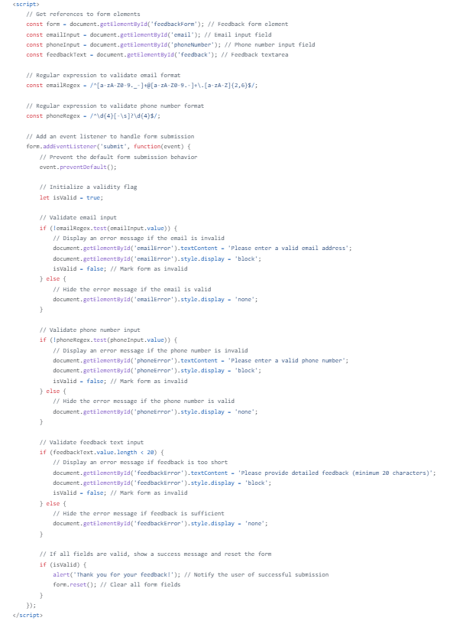

2. Calculation Page:

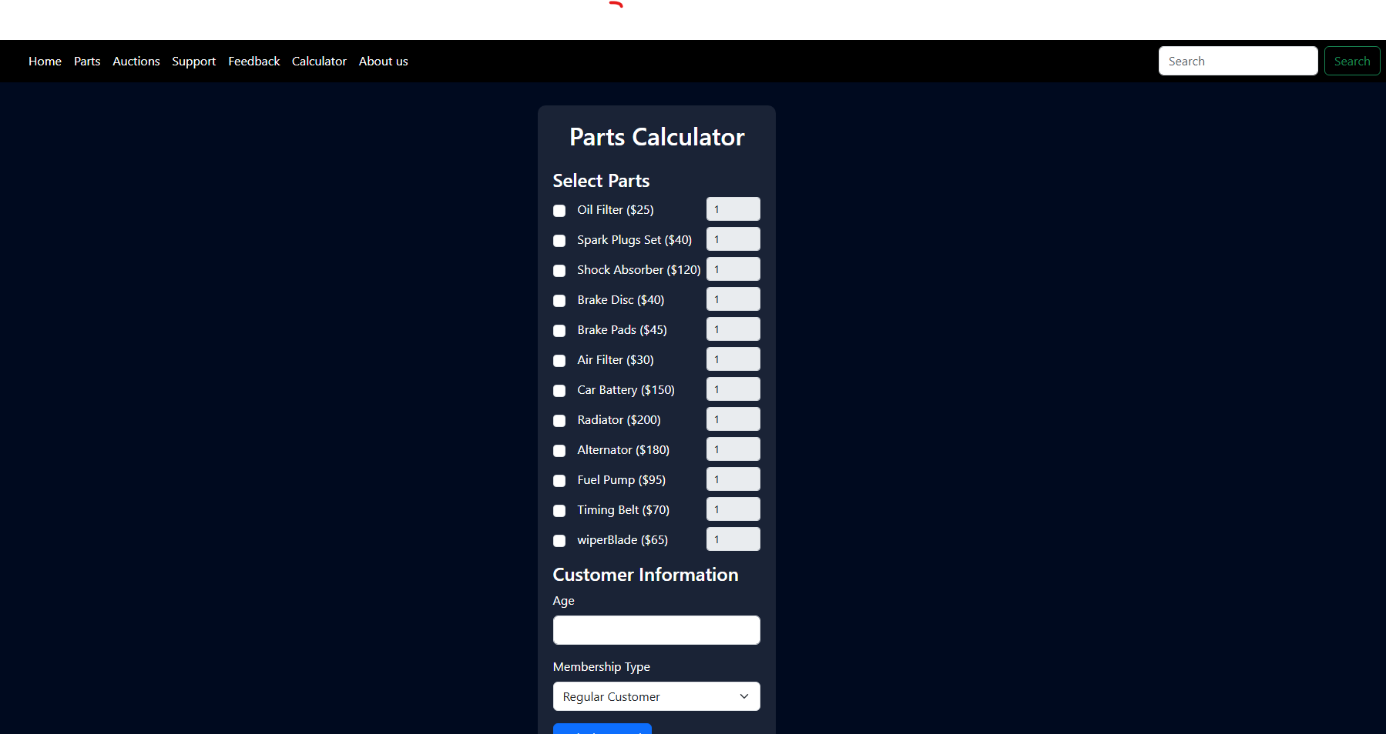

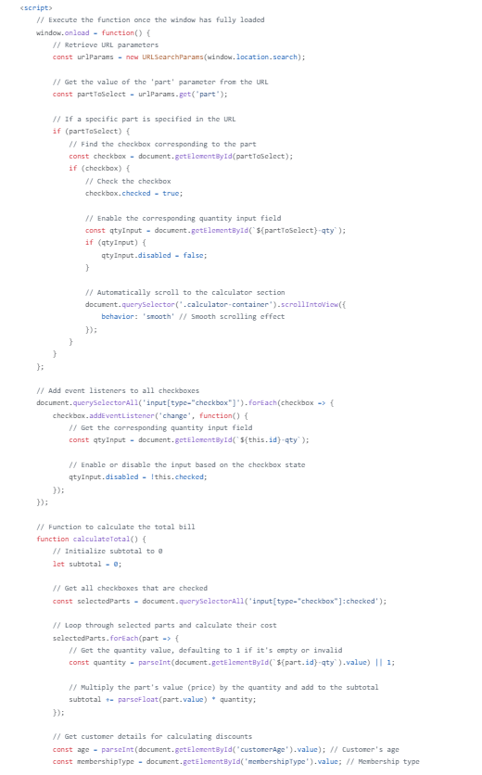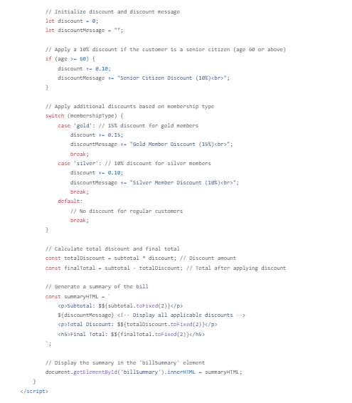

Updated Index Page:



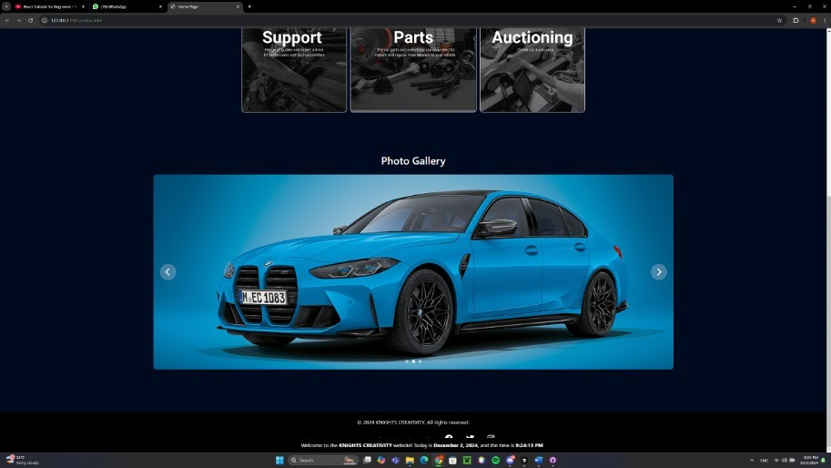

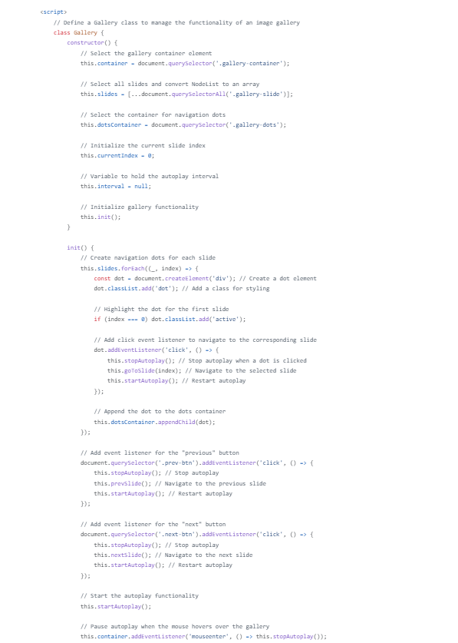

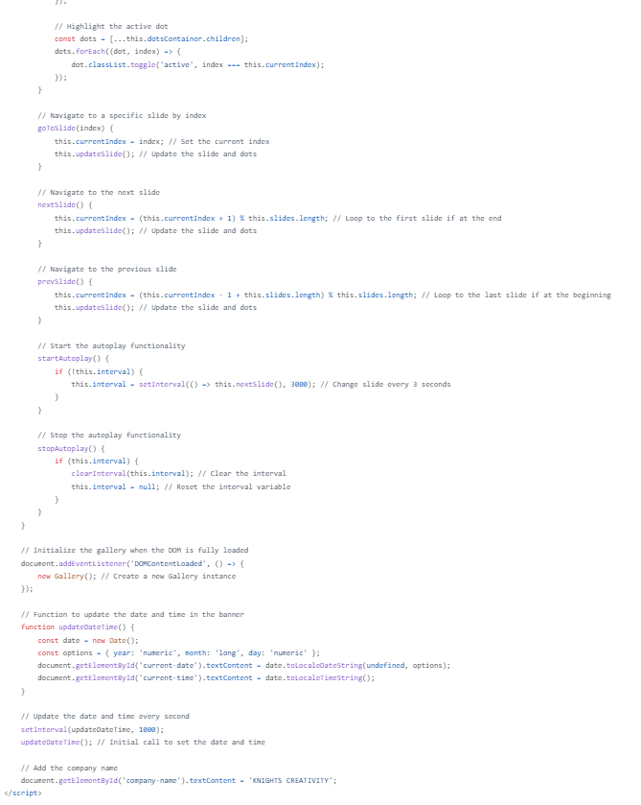

Funpage :

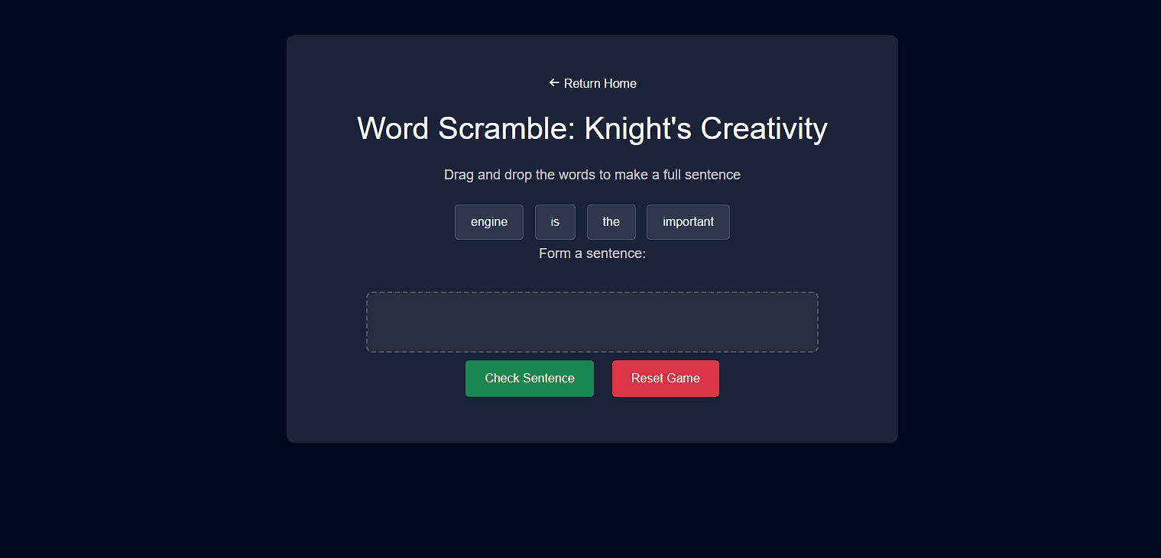

TABLES:

THE REACT PART/BONUS:

